SONGS OF PRAISE
IN AID OF ST Paul’s school, bo, sierra leone

SUNDAY 14th january @ 3.pm
In west wittering church
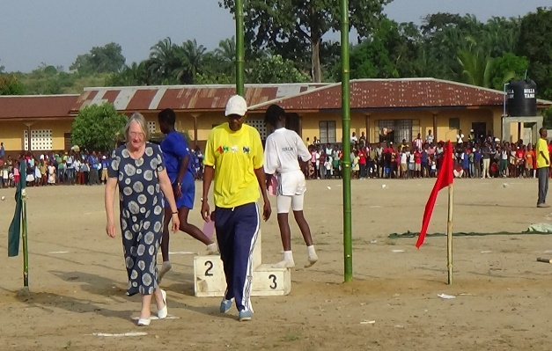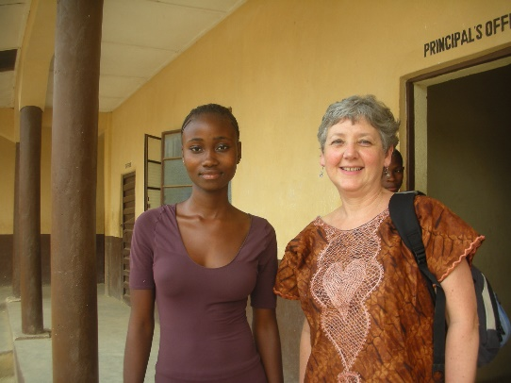
“BUILDING ON THE APPROVAL”
AFTER TEN YEARS OF HARD WORK APPROVAL HAS BEEN GRANTED TO CONDUCT SENIOR SECONDARY EDUCATION. COME CELEBRATE THE JOURNEY AND HELP BUILD A NEW FUTURE FOR THE CHILDREN, AND
Sing your favourite HYMNS
COLLECTION FOR ST PAUL’S SCHOOL, BO

