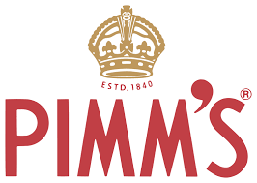
IN THE GARDEN Pimms & Canapés
in aid of St Paul’s School, Bo, Sierra Leone
SATURDAY 22nd September 5-7PM
LOCKS END HOUSE, LOCK LANE, BIRDHAM, PO20 7BB
TICKETS £15
from Jill – 07818420773; Linda – 07702 028968; Bruce – 514129 Pimms or soft drinks and Canapés from 5-7pm - wine bar on donation
Piano Accompaniment from Tim Parsons ABLE BODIED PARKING AT CHICHESTER MARINA, LIMITED PARKING IN THE DRIVE

