Welcome to the 2023 Newsletter from your Village Charity St Paul’s Secondary School, Bo, Sierra Leone

Back to Work.
During Covid life was difficult for everyone and fund-raising was almost impossible apart from sponsorship which thankfully remained constant, so our income fell considerably as was the case with all charities. Covid was also affecting the School too with lockdowns etc so that our expenditure dropped even more than our income and we actually accumulated funds which is helping our two major projects for this year (see below), both of which will be completed on our winter visit.

The Computer Lab and Six Classroom Block
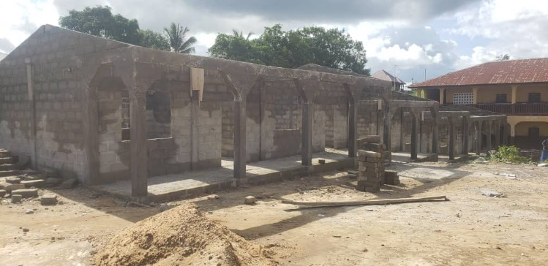
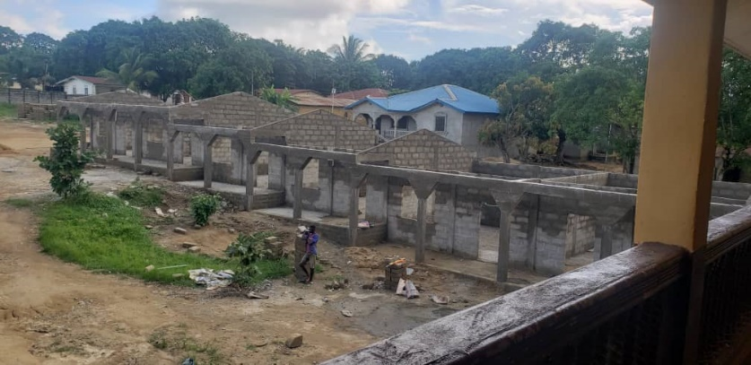
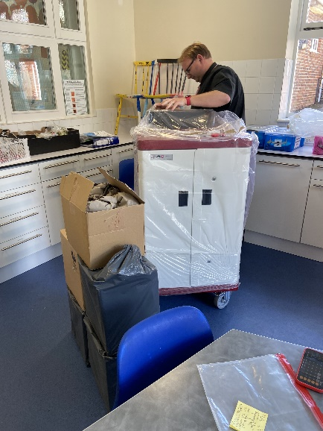
The lab has arrived, been paid for, been set up for school use, been delivered to the shipping agent, along with 1200 library books and sails for Sierra Leone on 23rd August, arriving in Freetown on 20th September where it will be collected and taken to Bo as the new school year starts. It will then be installed and the staff trained during our winter visit in November. Our Tech expert and head of WW Primary School, Nick, will be a busy man, installing the equipment and training the staff. The Lab includes 22 i-pads, a security cabinet, two 65” TV’s and untold numbers of techy bits and pieces which together and over time, will transform teaching in the school. The Sierra Leone government has decreed that all children must now attend secondary school, whereas when the project started it was only about one in five who were privileged to do so. Needless to say there are not the places for them all so to allow St Paul’s to meet its new obligations without class sizes going through the roof, we (thanks to your generosity), are building them a new 6-classroom block (see pictures) costing c.£30,000. This will mean pupil numbers rising to over 2,000, but will keep class sizes down to 50-80. We expect the new classrooms will be occupied by the start of the new school year.

The Visit
We plan to visit for ten days from 23 Nov – 2 Dec. Anyone wishing to join the group please contact Bruce Holben 514129, or Nick Matthews at the school. Cost is usually £12-1400, of which the airfare is the major part. It is not a holiday as such but a wonderful experience and a chance to get to know some of the poorest but happiest and most generous people you will ever meet. Everybody pulls their weight on the visit; but it is fun, opens new horizons, and is very rewarding. During the visit the computer lab will be installed and the teachers trained in its use, and Bruce will be installed as Canon of the Cathedral of Bo, which although an honour Bruce receives personally, is in effect intended as the highest honour the church can bestow on the whole village, because they know this is a village charity and they are so grateful. They tell us anyone from West Wittering and surrounds who appears in Bo will find every door is open to them. You deserve the accolade too for your generosity and support in so many ways over the nearly eighteen years of the project’s life; building, extending, and supporting the school and the poorest children. We will also be meeting as many of the children as possible, talking over the planned career creation scheme which is intended to help them into businesses and jobs, and spending time with them just listening to what they have to say and finding out how they live.

The Children
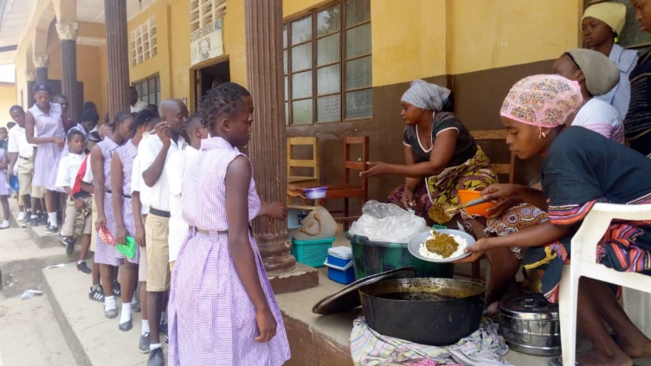
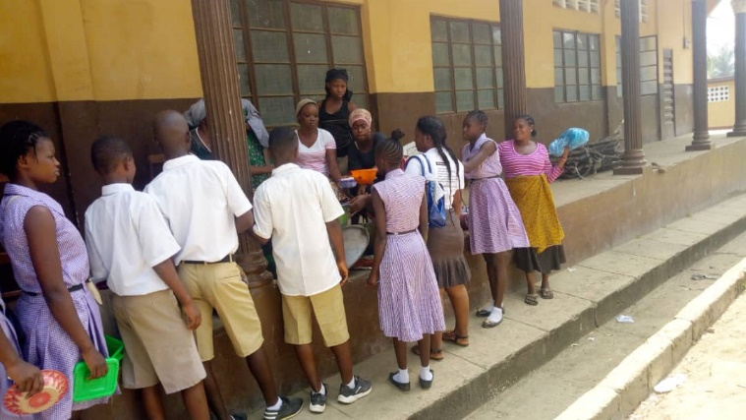
The School is doing well academically. Its last Basic School Certificate (BECE, our GCE) results put it in the top seven out of 100 similar schools in the Bo district; and in the Senior School Certificate exams it finished in the top three out of 60 schools. The sponsored children are doing well too, Augusta Vamboi came first overall in the BECE exams and many passed all 8 subjects. Thanks to your generosity we now sponsor c. 300 children providing them with books, uniforms, sports kit etc, as well as a school lunch, (below); often their only meal of the day, and which, thanks to your loyalty, allowed us to continue feeding the children throughout Sierra Leone’s lockdowns. More sponsors are always needed and at a cost of just £5 a month (less than a bottle of wine!), it is a wonderful way to give a child the chance of a fulfilled life.
Fundraising
We had a fantastic Quiz Night in the Spring raising over £3,000, with our brilliant quizmasters and cooks excelling themselves. It was a really fun evening and WILL be repeated due to popular request. Coming up on Sunday 17th September we are holding a lunchtime West Indian BBQ with WI music, a great WI menu, a welcoming drink of rum or fruit punch, a bar, and tombola/auction. Tickets are £25/head or £75 for a family of four. Children under 6 come f.o.c.
Songs of Praise service in West Wittering Church. This will be in the new year when we will update you on the November visit with lots of pictures and stories. We hope to see you there.

A huge thank you to everyone for your generosity. Together we are building a new community in Bo where children and young families can grow and prosper and become independent and self-reliant. There is a long way to go, but much has already been achieved through your support.

For information on the project, news of the school, the children and the fundraising events, and details on donation and sponsorship please visit our website – slbsa.co.uk.

Education, a gift for Life!

